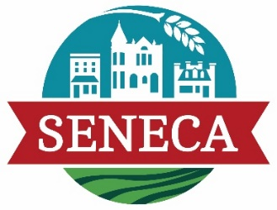
City of Seneca
COUNCIL MEETING AGENDA
January 2, 2025
7:30 p.m.

PRELIMINARY MATTERS
- Call to Order
- Roll Call
- Approve minutes of the regular meeting held on December 18, 2024
- Public Comment

HEARINGS & PETITIONS

ORDINANCES & RESOLUTIONS
- Appropriation Ordinance No. 1485

ACTION ITEMS
- Consideration of Pony Express Signage through Bureau of Land Management
- Consideration of 2 Cereal Malt Beverage Licenses
- Consideration of New Proposed Water Rates

DISCUSSION
- Wholesale Water Contract
- Update on Substation/Generation

REPORTS & RECOMMENDATIONS
- Finance, Personnel, & Services (Fire, Police, Recreation)
- Utilities, Streets, Facilities, and Land
- Economic Development, Code Enforcement, Planning & Zoning
- Other reports

ANNOUNCEMENTS
- Mayor
- City Administrator

EXECUTIVE SESSION
- Land Acquisition
- Contractual

ADJOURNMENT

